**DA  
Experiment 8**

bhoumik shah  
03  
1032220072

Title: VLOOKUP, HLOOKUP reference functions

Assignment 1

Dataset:

Questions:

1. VLOOKUP (Basic):

○ Use VLOOKUP to find the Department for Employee ID "E007" in

Table 1.

Formula: =VLOOKUP("E007", A2:C11, 3, FALSE)

○ Retrieve the Salary for "Liz Gray" (Employee ID "E008") using

VLOOKUP.

Formula: =VLOOKUP("E008", A2:D11, 4, FALSE)

2. VLOOKUP with an Exact Match:

○ Find the Location of the employee with Employee ID "E003"

using VLOOKUP.

Formula: =VLOOKUP(A4,Table1[[Employee ID]:[Location]],5,TRUE)

3. VLOOKUP with an Approximate Match:

○ In Table 1, suppose you need to classify employee salaries into

three categories:

■ Low for salaries less than 50,000

■ Medium for salaries between 50,000 and 70,000

■ High for salaries above 70,000

○ Use a helper table below and perform a VLOOKUP to classify each

employee’s salary.

4. Helper Table for Salary Classification:

HLOOKUP (Basic):

○ Use HLOOKUP to find the Avg. Salary for the Marketing

department from Table 2.

Formula: =HLOOKUP("Marketing",I2:L5,3,FALSE)

○ Retrieve the Employees count for the HR department using

HLOOKUP.

Formula: =HLOOKUP(I5,Table2,4,FALSE)

5. HLOOKUP with an Exact Match:

○ Using HLOOKUP, find the total budget for the IT department in

Table 2.

Formula: =HLOOKUP(I4,Table2,2,TRUE)

6. Combining VLOOKUP and HLOOKUP:

○ Use VLOOKUP to find the department of "Alice Green" (Employee

ID "E004") from Table 1, and then use HLOOKUP to find the Total

Budget for her department from Table 2.

Formulas: =VLOOKUP("E004", A2:F11, 3, FALSE)

=HLOOKUP("HR", H1:K3, 2, FALSE)

7. Dynamic Lookup (Advanced):

○ Create a dynamic lookup function where you can enter an

Employee ID in a separate cell, and Excel will return the

corresponding employee’s Name, Department, and Location

using VLOOKUP.

Formula: =VLOOKUP(M1, A2:F11, 2, FALSE)

=VLOOKUP(M1, A2:F11, 3, FALSE)

=VLOOKUP(M1, A2:F11, 5, FALSE)

Assignment 2

Dataset:

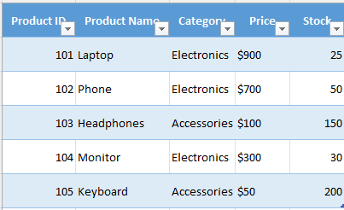

Questions:

1. find the price of the "Monitor".
   1. =VLOOKUP("Monitor", B2:E6, 3, FALSE)
   2. 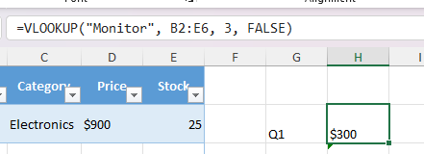
2. find the stock of Product ID "102"
   1. =HLOOKUP(Table1[@[Product ID]],Table1[Product ID],LEN(Table1[Product ID]),FALSE)
   2. 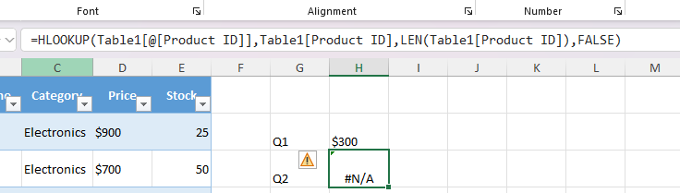
3. Find the product category of Product ID "105"
   1. =VLOOKUP(105, A2:E6, 3, FALSE)
   2. 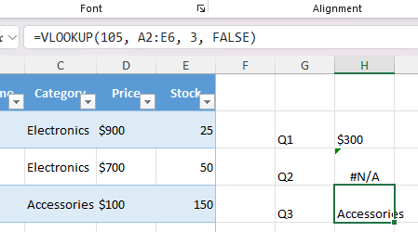
4. check if the stock for "Phone" is greater than 40?
   1. =VLOOKUP("Phone", B2:E6, 4, FALSE) > 40
   2. 